|  |  |
| --- | --- |
| ITB logo portrait B&W | INSTITUTE OF TECHNOLOGY BLANCHARDSTOWN  A Taster of Computing  [[VERSION – Unity 2D – C# language]] |

Gravity Guy 3D (2014) - a little computer game... now in 3D

Part 2 - projectiles

CONTENTS

1 Create a red-sphere projectile prefab (with a rigid body) 2

2 Create a projectile creator in 3rd Personal Controller GO 3

3 C# code listing: FireProjectile.cs 5

# Create a red-sphere projectile prefab (with a rigid body)

## Create a red material

Do the following:

* Create a new folder Materials in the **Project** panel
* Create new material named “m_red”
* Select this material, and in the **Inspector** set the Main Color to red

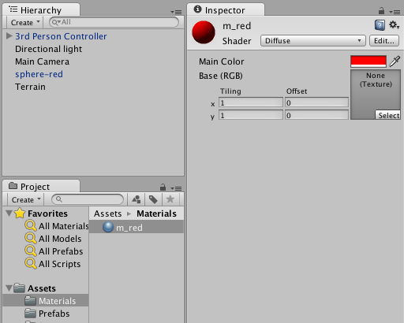

## Create your red sphere projectile

Do the following:

* In the **Hierarchy** add a new Sphere object, name it “Sphere – red”
* Add to the sphere a component: Physics > Rigidbody
* Drag your red material “m_red” from the **Project** panel over the “Sphere – red” gameObject

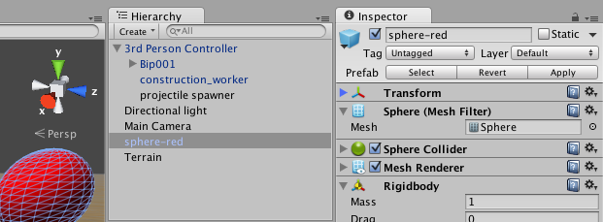

## Create a red sphere ‘prefab’ based on your game object

Do the following:

* In the **Project** panel, create a new prefab named “Sphere-red-prefab”
* Drag your “Sphere-red” gameObject from the **Inspector** into your new prefab
  + The prefab should turn blue to show it has now been populated
* You can now delete Sphere-red from the **Hierarchy**

# Create a projectile creator in 3rd Personal Controller GO

## Add a small, named sphere as a child of your 3rd person controller

Let’s create an object that will be the creator and point of origin for new projectiles

Do the following:

* Double click your 3rd Person Controller
  + And you may wish to zoom out a little
* Create a new sphere, located just in front of your 3rd Person controller
  + Name this sphere ‘projectile-spawner’
  + Make it smaller
  + Disable the Sphere Collider component
  + Disable the Mesh render component
* In the **Inspector** drag ‘projectile-spawner’ into 3rd Person Controller, so that it becomes a ‘child’ of the 3rd Person Controller game object

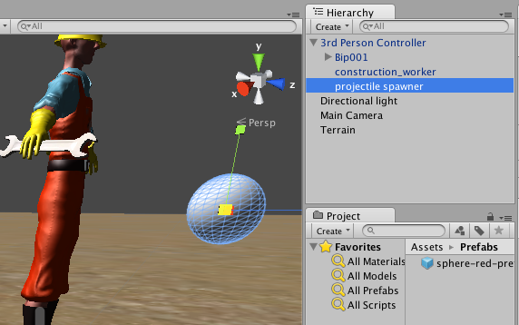

## Import the FireProjectile script from Matt’s book

Do the following:

* Create folder Scripts
* Drag the FireProjectile script into this folder
* Add an instance of this script class as a component of your new **projectile-spawner** sphere inside your 3rd Person Controller
  + When the scripted component appears in the Inspector, drag your **Sphere-red-prefab** from your Prefabs folder into the public variable ProjectilePrefab

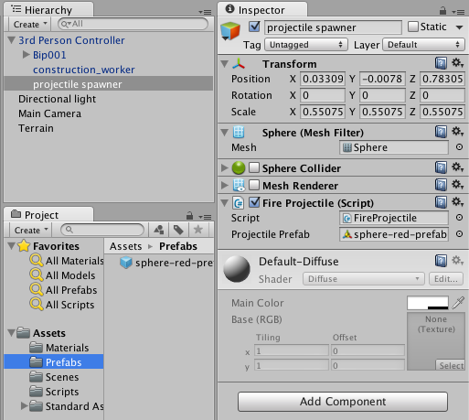

## Playtest your game

Run the game, and fire red spheres by pressing the LEFT-CTRL key

## Tweaking …

You might wish to ‘tweak’ the following:

* Change object being thrown to a different prefab
  + e.g. a 3D object like a knife, apple etc.
  + or a small cube, or smaller sphere etc.
* Make projectiles move faster
  + by increasing the value of projectileSpeed in script **FireProjectile.cs**
* Make the projectile fire upwards at at angle
  + By rotating the **projectile spawner object** inside 3rd Person Controller – projectiles will be fired in the direction of the **BLUE arrow**
  + So ROTATE the projectile spawner object and switch to MOVE mode to see your 3 xyz (red-green-blue) coordinate arrows
* Change the fire key
  + Menu **Edit | Project Settings | Input**, then change the Inspector value for Axis **Fire1**
* **Autodestroy** projectiles after 1.5 seconds
  + add this line at the end of method **CreateProjectile():**
    - **Destroy( projectile.gameObject, 1.5f);**

# C# code listing: FireProjectile.cs

**// file: FireProjectile.cs**

**using UnityEngine;**

**using System.Collections;**

**public class FireProjectile : MonoBehaviour**

**{**

**public Rigidbody projectilePrefab;**

**private const float MIN_Y = -1;**

**private float projectileSpeed = 15f;**

**/** shortest time between firing */**

**public const float FIRE_DELAY = 0.25f;**

**private float nextFireTime = 0f;**

**private void Update()**

**{**

**if( Time.time > nextFireTime )**

**CheckFireKey();**

**}**

**private void CheckFireKey()**

**{**

**if( Input.GetButton("Fire1"))**

**{**

**CreateProjectile();**

**// enssure a delay before next projectile can be fired**

**nextFireTime = Time.time + FIRE_DELAY;**

**}**

**}**

**private void CreateProjectile()**

**{**

**Rigidbody projectile = (Rigidbody)Instantiate(projectilePrefab, transform.position, transform.rotation);**

**// create and apply velocity**

**Vector3 projectileVelocity = (projectileSpeed * Vector3.forward);**

**// - need to use TransformDirection() so direction is**

**// releative to current direction camera is facing**

**projectile.velocity = transform.TransformDirection( projectileVelocity );**

**}**

**}**